# COMP 3612 Assignment #2: Single-Page App

#### Version: 1.0 Oct 6, 2022 Due Saturday November 13, 2022 at midnightish

## Overview

This assignment provides an opportunity for you to demonstrate your ability to work with JavaScript. The application you will be creating is a viewer of song data from 2016-2019 (sorry about living in the past but this is the data I was able to find easily). You can work in pairs or by yourself. Please don’t ask me to be in a group of 3.

## Beginning

It is your responsibility to read all the assignment instructions thoroughly and carefully. If you are unclear about something, ask me. But before you do, read the material in question again!

Starting files can be found (eventually) at:   
 https://github.com/mru-comp3612-archive/f2022-assign2.git

## Grading

The grade for this assignment will be broken down as follows:

Visual Design 15%  
Programming Design 15%

Functionality (follows requirements) 70%

## Requirements

This assignment consists of a single HTML page (hence single-page application or SPA) with the following functionality:

1. Your assignment should have just a single HTML page which must be named index.html.
2. The assignment should have three main views: **Search/Browse Songs, Song Details,** and **Playlist**. When the program first starts, display the **Search Songs** view.
3. There are two sources of data. The first are JSON files containing a list of genres and a list of artists/groups. Exercise 8.14 in Lab 8 provides instructions for converting a JSON file into a string and then using JSON.parse() to convert it into a JavaScript object.  
     
   The other source of data is the song API that provides a list of about 400 songs. Each song includes Spotify analysis information. You will also be provided a JSON file containing a small subset of songs so you can test without the API (though your submitted assignment must consume the data from the API). The API can be found (eventually) at:  
     
   http://www.randyconnolly.com/funwebdev/3rd/api/music/songs-nested.php
4. **Make sure you are only requesting/fetching the song data once!** To improve the performance of your assignment (and reduce the number of requests on my server), you must store the song data in localstorage after you fetch it from the API (see Exercise 10.11 in Lab 10). Your page should thus check if this play data is already saved in local storage: if it is then use local data, otherwise fetch it and store it in local storage. This approach improves initial performance by eliminating this first fetch in future uses of the application. Be sure to test that your application works when local storage is empty before submitting (you can empty local storage in Chrome via the Application tab in DevTools).
5. **Search/Browse Songs view**. You will implement a page with similar functionality as that described below. The provided sketch below illustrates the functionality. You are welcome to modify the design as you see fit. This view doesn’t have to say “Browse/Search Results”; it, and the other bold labels on these pages, are there to explain what functionality must be on the page, not necessarily the actual labels that must appear on your page.

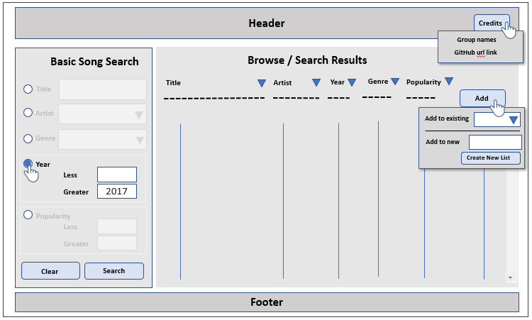  
For each song in the list, display the song title, artist name, year, genre name, and popularity number. Style the song title so it looks like a hyperlink. When the user clicks on a song title, the view should change to **Single Song View**.

Initially display the songs sorted by their title. If the user clicks on the column headings, sort the list on the clicked field. The list should refresh whenever the user changes the sort option. The list must be an unordered list; the list must be made scrollable by setting the overflow-y property of the container to scroll.

Provide an icon/link/button that allows the user to add that song to a playlist. When the user clicks this icon/link/button, then display a pop-up panel that allows the user to either add the song to an existing playlist (via a <select> list) or add it to a new playlist (the playlist must be given a **unique** name before you enable the Create New List buton. If the user clicks outside of the panel, then hide the panel. The best way to implement a panel is to define it as a <div> in the markup and then programmatically hide/show it using the display property. Be sure as well to set its css position programmatically based on click coordinates. When the user adds a song to a playlist, hide the panel and then display a different pop-up panel that tells the user the song was added to a playlist, but hide it after a few seconds. Using CSS transitions for these panel transitions will make it look quite professional. Be sure to use event delegation for all this pop-up panel functionality!

The page also needs to provide a way to filter the songs. The user should be able to filter the songs by title (does the word appear anywhere in the title?), artist name, genre, year, or popularity score. These options should be mutually exclusive and be enabled/disabled based on the current state of the radio buttons. The radio button should initially default to title. The clear button should remove any filters. You will find the array filter() function will be your friend here.

1. **Single Song view.** I would expect you to group and present this data in an intelligent way. For instance, no user would like to see the duration listed as it is in the database (number of seconds); instead they would expect to see number of minutes and seconds. Don’t be afraid of boxes, font contrast, color contrast, icons, progress bars, etc.

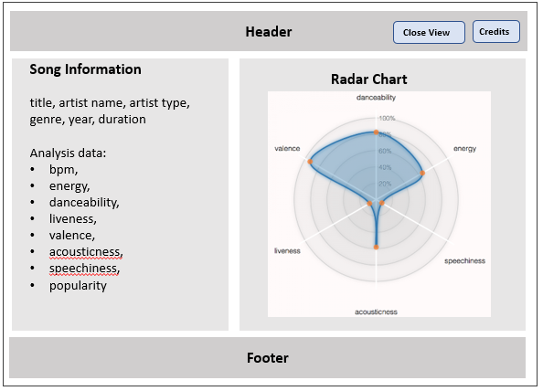

For each song, there is a variety of Spotify music analysis metrics, which are:

• bpm: The overall estimated tempo of a track in beats per minute (BPM).

• energy: Represents a perceptual measure of intensity and activity. Typically, energetic tracks feel fast, loud, and noisy. For example, death metal has high energy, while a Bach prelude scores low on the scale. Value between 1 and 100.

• danceability: Describes how suitable a track is for dancing based on a combination of musical elements including tempo, rhythm stability, beat strength, and overall regularity. Value between 1 and 100.

• valence: Describes the musical positiveness conveyed by a track. Tracks with high valence sound more positive (e.g. happy, cheerful, euphoric), while tracks with low valence sound more negative (e.g. sad, depressed, angry). Value between 1 and 100.

• liveness: Detects the presence of an audience in the recording. Higher liveness values represent an increased probability that the track was performed live. Value between 1 and 100.

• acousticness: A confidence measure of whether the track is acoustic. Value between 1 and 100.

• speechiness: This detects the presence of spoken words in a track. The more exclusively speech-like the recording (e.g. talk show, audio book, poetry), the closer to 100 the attribute value. Value between 1 and 100.

• loudness: The overall loudness of a track in decibels (dB). Loudness values are averaged across the entire track and are useful for comparing relative loudness of tracks. Not used in this assignment.

• duration: The duration of the track in seconds.

• popularity: The higher the number (closer to 100), the more popular the track.  
  
Display danceability, energy, valence, speechiness, loudness, and liveness in a radar chart. You can decide the order of the different axis values, the colors, the style, etc. I would recommend using the chart.js library (https://www.chartjs.org/), though you are welcome to use something else.

The Close View button will return the user to the **Search/Browse Songs View**.

1. **Playlist View**. This view consists of a list of playlists (on the left in the sketch below) and the contents of the selected playlist (on the right). If you want to replicate the sort functionality of your Search/Browse page, go ahead: I don’t however require sorting here. The user should be able to remove any song from a playlist. As well, there should be a way to delete a playlist. Also display some summary info about the selected playlist (i.e., the number of songs in the list and the average popularity).

For each song in the list, display the song title, artist name, year, genre name, and popularity number. Style the song title so it looks like a hyperlink. When the user clicks on a song title, the view should change to **Single Song View**.

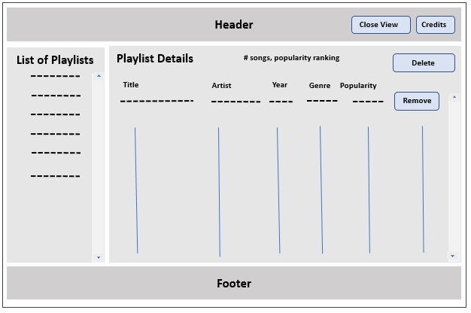

1. Header. Add an icon/button/label to the header named Credits. If the user moves the **mouses over** the credits button/link, then display a pop-up panel that displays the group member names as well as a link to the assignment’s github page. It should disappear after 5 seconds (use setTimeout).
2. You must write your own JavaScript. That is, no jQuery, no Bootstrap, no other third-party JavaScript libraries other than the one used for your charts. You have all the knowledge you need from the lectures and the three JavaScript labs to complete this assignment. If you do find yourself, however, making use of some small snippet of code you found online (and I do mean small), then you must provide references (i.e., specify the URL where you found it) via comments within your .js file. Failure to properly credit other people’s work in your JavaScript will result in a zero grade. Using ancient JavaScript found online will result in lower marks. There is no need to credit code you found in the labs or lectures.
3. You can use a third-party CSS library.

## Testing

Every year students lose many easy marks because they didn’t read the requirements carefully enough. When your assignment is getting close to done, I would recommend going through each requirement step and carefully evaluate whether your assignment satisfies each specified requirement.

## Submitting and Hosting

Your assignment source code must reside on GitHub and reside on a working public server (in this case GitHub Pages).

GitHub Pages works in conjunction with git and github. You push your html/css/images to github repo; and then push to the host. The instructions for doings so can be found at:  
  
https://docs.github.com/en/pages/getting-started-with-github-pages/creating-a-github-pages-site

It is up to you whether you want your pages to be public (available to the world) or private (available to only those with access to your github repo).   
  
If you are using a private repo, you must add me as a collaborator!

**I would strongly recommend getting your hosting to work a few days before the due date. It’s okay if your assignment is still not complete at that point: the idea here is to make sure hosting works ahead of time!**

When your hosting is working and the assignment is ready to be marked, then send me an email with the following information:

* The URL of the home page of the site on github pages.
* The URL of the github repo so that I can mark the source code. If your repo is private, then add me as a collaborator.

## Hints

1. Begin by testing the API out first in the browser. Simply copy and paste the URL into the browser address bar. The JSON can be hard to understand because it doesn’t have white space, so use an online JSON formatter (such as https://jsonformatter.curiousconcept.com) via copy and paste to see the JSON structure in an easier to understand format. Alternately, install a json viewer extension in Chrome.
2. Remember that JSON and JavaScript are case sensitive. For instance, it is easy to type in Energy and it won’t work because the JSON field is actually energy.
3. Your index.html file will include the markup for all three views. Your JavaScript code will programmatically hide/unhide (i.e., change the display value) the relevant markup container for the three views.
4. Most of your visual design mark will be determined by how much effort you took to make the views look well designed. Simply throwing up the data with basic formatting will earn you minimal design marks.
5. Most years, students tend to get low marks on the design side of the assignment. I would recommend looking at other sites on the internet and examine how they present data. Notice the use of contrast (weight, color, etc) and spacing.
6. Most of your programming design mark will be based on my assessment of your code using typical code review criteria. For instance, did you modularize your code using functions? Are your functions too long? Is the code documented? Do you have code duplication (you shouldn’t)? Did you make use of object-oriented techniques? Are variables and functions sensibly named? Is your code inefficient (e.g., fetching the same data repeatedly)? Are you using outdated JavaScript techniques (e.g., inline coding, XmlHttpRequest, etc)? Is the code excessively reliant on found code from Stack Overflow, etc?